ArgoCD Canary Rollout with ConfigMap checksum annotations.
Implemented GitOps-managed progressive delivery using ArgoCD and Argo Rollouts. Introduced ConfigMap checksum annotations to trigger rollouts on configuration changes, validated canary traffic progression from 25% to 100%
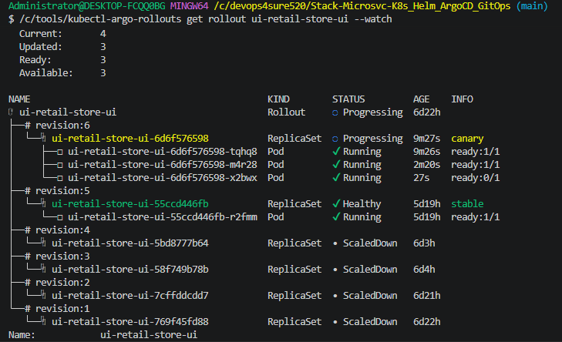
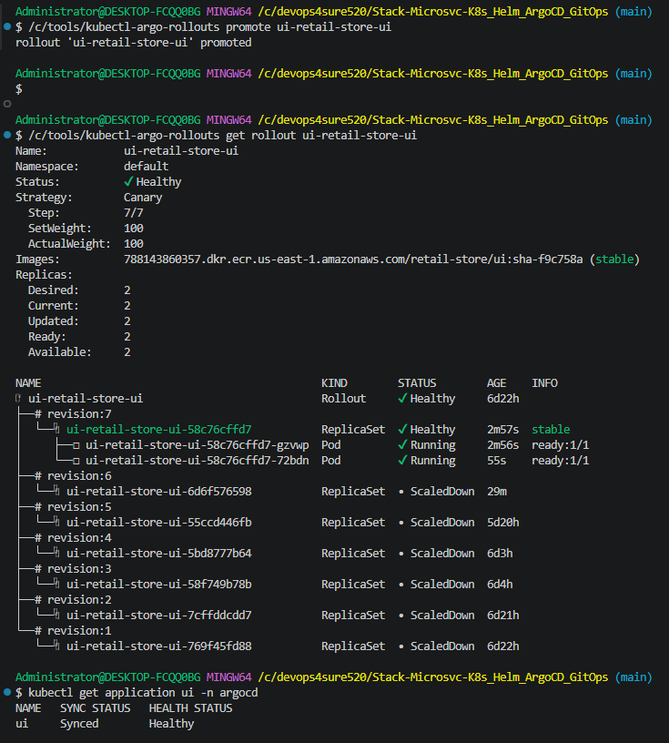
Administrator@DESKTOP-FCQQ0BG MINGW64 /c/devops4sure520/Stack-Microsvc-K8s_Helm_ArgoCD_GitOps (main)
$ kubectl describe rollout ui-retail-store-ui
Name: ui-retail-store-ui
Namespace: default
Labels: app.kubernetes.io/instance=ui
app.kubernetes.io/managed-by=Helm
app.kubernetes.io/name=retail-store-ui
app.kubernetes.io/version=1.16.0
helm.sh/chart=retail-store-ui-0.1.0
Annotations: argocd.argoproj.io/tracking-id: ui:argoproj.io/Rollout:default/ui-retail-store-ui
rollout.argoproj.io/revision: 7
API Version: argoproj.io/v1alpha1
Kind: Rollout
Metadata:
Creation Timestamp: 2026-06-09T00:26:44Z
Generation: 15
Resource Version: 6836851
UID: bf4675c6-752f-4283-9ee8-1f4841bc318b
Spec:
Replicas: 2
Selector:
Match Labels:
app.kubernetes.io/instance: ui
app.kubernetes.io/name: retail-store-ui
Strategy:
Canary:
Canary Service: ui-canary
Max Surge: 25%
Max Unavailable: 25%
Stable Service: ui-stable
Steps:
Set Weight: 25
Pause:
Set Weight: 50
Pause:
Set Weight: 75
Pause:
Set Weight: 100
Template:
Metadata:
Annotations:
checksum/config: 0f322632da8400d9810943413aa259e81955973c9b0849f015f2650654a4a4dd
instrumentation.opentelemetry.io/inject-sdk: default-instrumentation
Labels:
app.kubernetes.io/instance: ui
app.kubernetes.io/name: retail-store-ui
Spec:
Containers:
Env From:
Config Map Ref:
Name: ui-retail-store-ui
Image: 788143860357.dkr.ecr.us-east-1.amazonaws.com/retail-store/ui:sha-f9c758a
Image Pull Policy: IfNotPresent
Liveness Probe:
Http Get:
Path: /actuator/health/liveness
Port: 8080
Initial Delay Seconds: 30
Period Seconds: 10
Name: ui-retail-store-ui
Ports:
Container Port: 8080
Name: http
Protocol: TCP
Readiness Probe:
Http Get:
Path: /actuator/health/readiness
Port: 8080
Initial Delay Seconds: 10
Period Seconds: 5
Resources:
Limits:
Cpu: 512m
Memory: 1Gi
Requests:
Cpu: 256m
Memory: 512Mi
Security Context:
Allow Privilege Escalation: false
Capabilities:
Drop:
ALL
Read Only Root Filesystem: true
Run As Non Root: true
Run As User: 1000
Seccomp Profile:
Type: RuntimeDefault
Startup Probe:
Failure Threshold: 60
Http Get:
Path: /actuator/health/readiness
Port: 8080
Period Seconds: 10
Volume Mounts:
Mount Path: /tmp
Name: tmp-volume
Node Selector:
karpenter.sh/capacity-type: spot
Security Context:
Fs Group: 1000
Service Account Name: ui
Termination Grace Period Seconds: 30
Topology Spread Constraints:
Label Selector:
Match Labels:
app.kubernetes.io/component: service
app.kubernetes.io/instance: ui
app.kubernetes.io/name: ui
Max Skew: 1
Topology Key: kubernetes.io/hostname
When Unsatisfiable: ScheduleAnyway
Label Selector:
Match Labels:
app.kubernetes.io/component: service
app.kubernetes.io/instance: ui
app.kubernetes.io/name: ui
Max Skew: 1
Topology Key: topology.kubernetes.io/zone
When Unsatisfiable: DoNotSchedule
Volumes:
Empty Dir:
Medium: Memory
Name: tmp-volume
Status:
HPAReplicas: 2
Available Replicas: 2
Blue Green:
Canary:
Conditions:
Last Transition Time: 2026-06-15T22:56:43Z
Last Update Time: 2026-06-15T22:56:43Z
Message: Rollout has minimum availability
Reason: AvailableReason
Status: True
Type: Available
Last Transition Time: 2026-06-15T23:24:31Z
Last Update Time: 2026-06-15T23:24:31Z
Message: Rollout is paused
Reason: RolloutPaused
Status: False
Type: Paused
Last Transition Time: 2026-06-15T23:24:32Z
Last Update Time: 2026-06-15T23:24:32Z
Message: Rollout is healthy
Reason: RolloutHealthy
Status: True
Type: Healthy
Last Transition Time: 2026-06-15T23:24:31Z
Last Update Time: 2026-06-15T23:24:32Z
Message: ReplicaSet "ui-retail-store-ui-58c76cffd7" has successfully progressed.
Reason: NewReplicaSetAvailable
Status: True
Type: Progressing
Last Transition Time: 2026-06-15T23:24:32Z
Last Update Time: 2026-06-15T23:24:32Z
Message: RolloutCompleted
Reason: RolloutCompleted
Status: True
Type: Completed
Current Pod Hash: 58c76cffd7
Current Step Hash: 5f99bd9c68
Current Step Index: 7
Observed Generation: 15
Phase: Healthy
Ready Replicas: 2
Replicas: 2
Selector: app.kubernetes.io/instance=ui,app.kubernetes.io/name=retail-store-ui
Stable RS: 58c76cffd7
Updated Replicas: 2
Events:
Type Reason Age From Message
---- ------ ---- ---- -------
Normal NewReplicaSetCreated 34m rollouts-controller Created ReplicaSet ui-retail-store-ui-6d6f576598 (revision 6)
Normal ScalingReplicaSet 34m rollouts-controller Scaled up ReplicaSet ui-retail-store-ui-6d6f576598 (revision 6) from 0 to 1
Normal RolloutNotCompleted 34m rollouts-controller Rollout not completed, started update to revision 6 (6d6f576598)
Normal RolloutUpdated 34m rollouts-controller Rollout updated to revision 6
Normal ScalingReplicaSet 34m rollouts-controller Scaled up ReplicaSet ui-retail-store-ui-55ccd446fb (revision 5) from 2 to 3
Normal SwitchService 34m rollouts-controller Switched selector for service 'ui-canary' from '55ccd446fb' to '6d6f576598'
Normal ScalingReplicaSet 27m rollouts-controller Scaled down ReplicaSet ui-retail-store-ui-55ccd446fb (revision 5) from 3 to 2
Normal RolloutStepCompleted 27m (x2 over 6d4h) rollouts-controller Rollout step 2/7 completed (pause)
Normal ScalingReplicaSet 27m rollouts-controller Scaled up ReplicaSet ui-retail-store-ui-6d6f576598 (revision 6) from 1 to 2
Normal RolloutStepCompleted 27m (x2 over 6d4h) rollouts-controller Rollout step 3/7 completed (setWeight: 50)
Normal ScalingReplicaSet 25m rollouts-controller Scaled down ReplicaSet ui-retail-store-ui-55ccd446fb (revision 5) from 2 to 1
Normal RolloutStepCompleted 25m (x2 over 6d4h) rollouts-controller Rollout step 4/7 completed (pause)
Normal ScalingReplicaSet 25m rollouts-controller Scaled up ReplicaSet ui-retail-store-ui-6d6f576598 (revision 6) from 2 to 3
Normal RolloutPaused 25m (x7 over 6d21h) rollouts-controller Rollout is paused (CanaryPauseStep)
Normal RolloutStepCompleted 25m (x2 over 6d4h) rollouts-controller Rollout step 5/7 completed (setWeight: 75)
Normal RolloutStepCompleted 25m (x2 over 6d4h) rollouts-controller Rollout step 6/7 completed (pause)
Normal RolloutStepCompleted 25m (x2 over 6d4h) rollouts-controller Rollout step 7/7 completed (setWeight: 100)
Normal ScalingReplicaSet 25m rollouts-controller Scaled down ReplicaSet ui-retail-store-ui-55ccd446fb (revision 5) from 1 to 0
Normal RolloutCompleted 25m rollouts-controller Rollout completed update to revision 6 (6d6f576598): Completed all 7 canary steps
Normal SwitchService 25m rollouts-controller Switched selector for service 'ui-stable' from '55ccd446fb' to '6d6f576598'
Normal ScalingReplicaSet 20m rollouts-controller Scaled down ReplicaSet ui-retail-store-ui-6d6f576598 (revision 6) from 3 to 2
Normal RolloutUpdated 8m52s rollouts-controller Rollout updated to revision 7
Normal NewReplicaSetCreated 8m52s rollouts-controller Created ReplicaSet ui-retail-store-ui-58c76cffd7 (revision 7)
Normal RolloutNotCompleted 8m52s rollouts-controller Rollout not completed, started update to revision 7 (58c76cffd7)
Normal ScalingReplicaSet 8m51s rollouts-controller Scaled up ReplicaSet ui-retail-store-ui-58c76cffd7 (revision 7) from 0 to 1
Normal RolloutStepCompleted 8m10s (x3 over 6d4h) rollouts-controller Rollout step 1/7 completed (setWeight: 25)
Normal SwitchService 8m10s rollouts-controller Switched selector for service 'ui-canary' from '6d6f576598' to '58c76cffd7'

Administrator@DESKTOP-FCQQ0BG MINGW64 /c/devops4sure520/Stack-Microsvc-K8s_Helm_ArgoCD_GitOps (main)
Latest image tagged and pushed to ECR
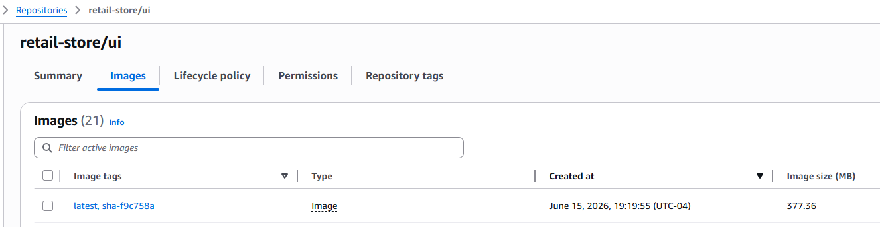
GitOps workflow completed successfully with git commit id
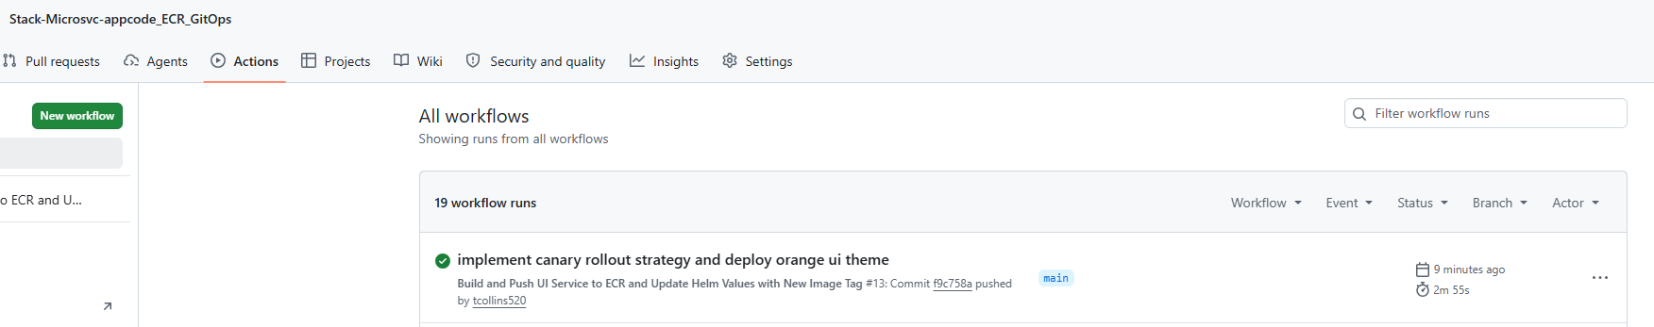
ArgoCD in sync with EKS cluster live state:
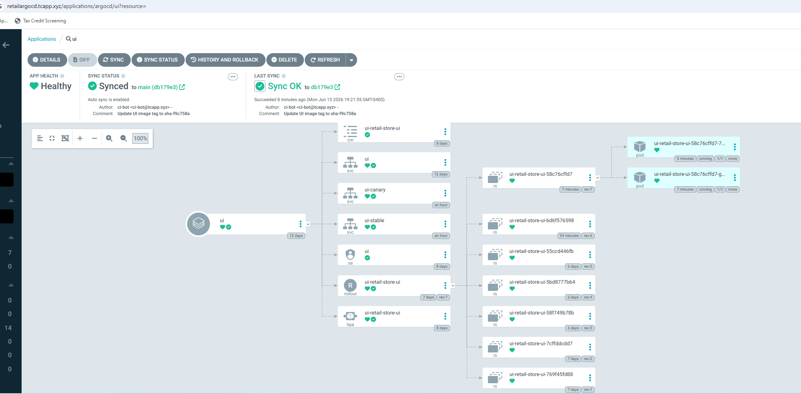
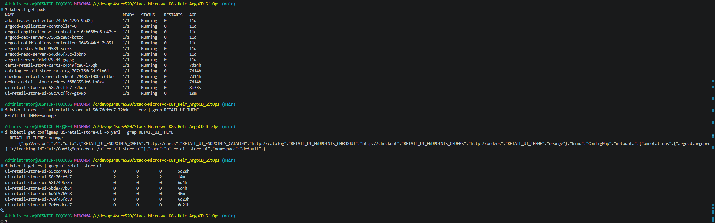
App theme color changed to Orange!
